Interaction Flow of application

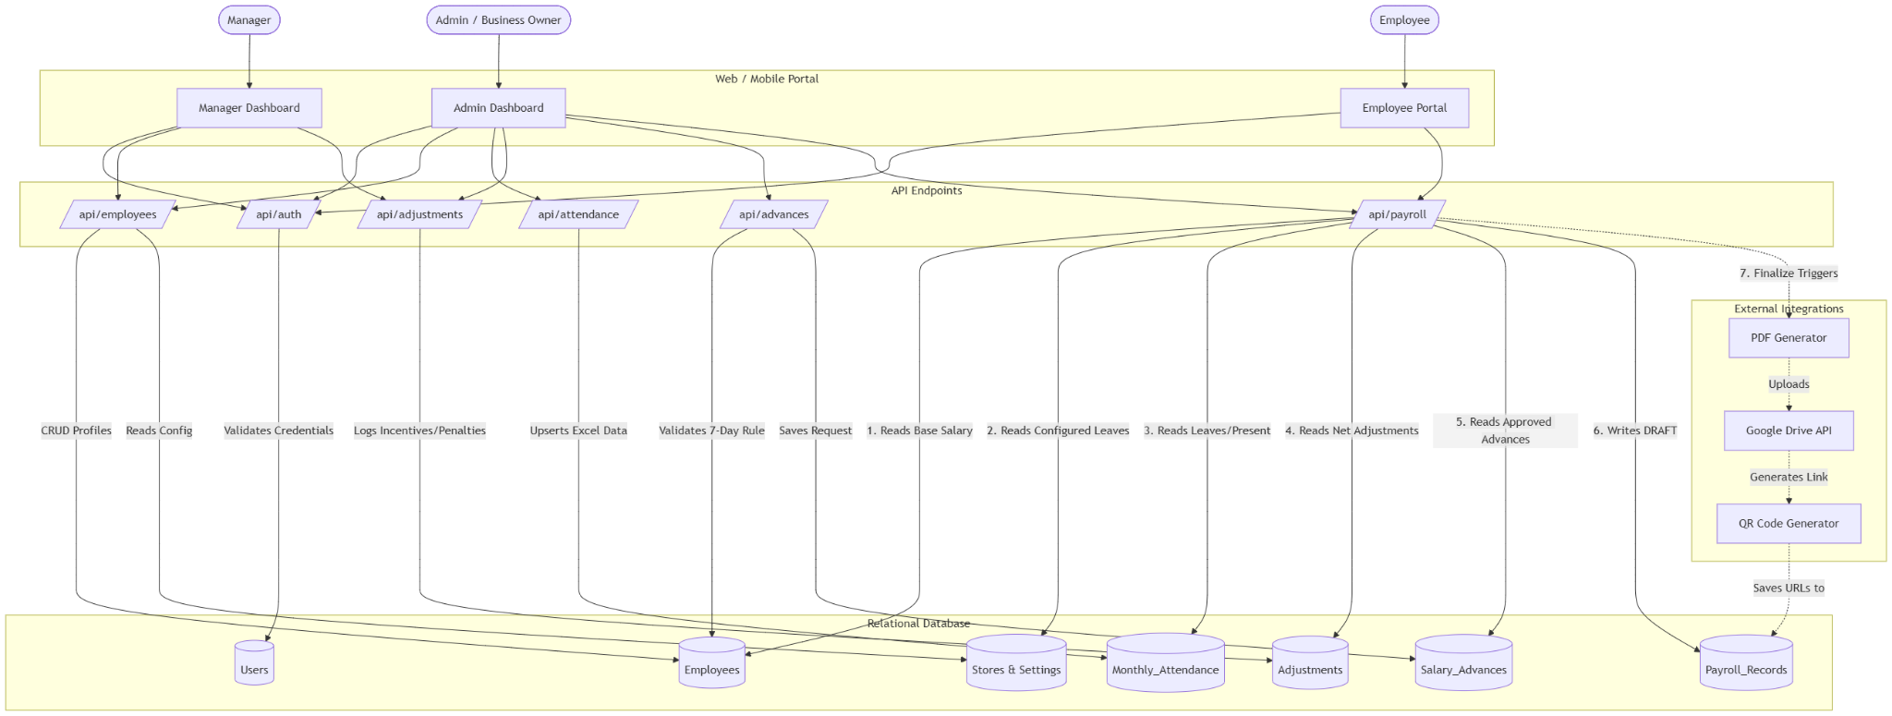

Step-by-Step Interaction Breakdown
1. Setup & Authentication Phase
- Users (Admin/Manager) log in via the /api/auth/ endpoint, which checks the Users table and returns a token with their role and accessible store_id.
- The Admin uses the /api/employees/ endpoint to create staff profiles. This writes to the Employees table and automatically creates a login credential in the Users table.
2. Mid-Month Operations
- Adjustments: Managers/Admins use the UI to log daily or monthly Overtime, Incentives, and Penalties via /api/adjustments/. These are stored in the Adjustments table, waiting for month-end.
- Advances: An employee requests an advance. The Admin logs it via /api/advances/request. The backend fetches the employee's base salary from Employees, calculates the per-day wage, applies the (Date - 7) rule, and saves the approved amount to Salary_Advances.
3. Month-End Data Ingestion
- The Admin uploads the attendance Excel sheet to /api/attendance/upload. The API parses the rows and populates the Monthly_Attendance table with total days present and total leaves for that specific month and year.
4. The Core Computation ("The Engine")
- The Admin clicks "Compute" triggering /api/payroll/compute.
- The API acts as an aggregator:
  - It fetches the default_paid_leaves from Store_Settings.
  - It pulls the base salary from Employees.
  - It pulls the uploaded attendance from Monthly_Attendance.
  - It sums up all rows for that month in Adjustments.
  - It sums up all approved rows for that month in Salary_Advances.
- It runs the math (Per-day salary calculation, Unpaid leave deductions, Final Net Salary) and writes a DRAFT record to the Payroll_Records table.
5. Finalization & Post-Processing
- The Admin reviews the preview and triggers /api/payroll/finalize.
- The system changes the status in Payroll_Records to FINALIZED.
- This triggers a background task that sends the data to a PDF Generator.
- The PDF is uploaded to Google Drive, a QR code is generated for that Drive link, and both URLs are saved back into the Payroll_Records table.
- Employees can now log in, hit the /api/employee/payslips endpoint, and view/download their PDFs.

